1.INTRODUCTION

1.1 PROBLEM DEFINITION

One of the fastest growing industries now a day is mobile industry. There are many Competitors in this area who are doing research and development on new platforms & user Experience. One such technology is Android from Google which is supported for many manufactured phones. These phones are described as next Generation mobiles [As described by Google].
Personal Account tracker is an application which helps the user in tracking all the deposits and withdrawals of his bank account. Also he can store multiple account details. Using this application, he can know the balance amount in his multiple accounts. The user needs to store all his bank account details and the balance amount in that account. Whenever the user deposit or withdraw money from the account, he has to enter the transaction details and save it so that when he opens the app, the balance amount in each account will be displayed. He can also search for the transactions date wise and amount wise.. This application supports 2.3 version of android frame work.

1.2 EXISTING SYSTEM:

In android mobiles, we do not have any app which can store the account details, transaction details and shows the balance amount in multiple accounts.if we want to search multiple account details then we have to go banks to check the multiple transaction details.
.
DisAdvantages
- Wastage of time to go to bank to check our transaction details.
- Searching the deatils is very hard.
- Deposit,Withdrawal details only checking by going to banks.

1.3 PROPOSED SYSTEM

In the proposed system, the user can store the details of multiple accounts and the transaction details of these accounts. He can also search the transactions date wise and amount wise if necessary. The user can know the balance amount in each account by just opening this application.

1.3.1 Modules
- Module1:Add Account
- Module2:Add new Transaction
- Module3: View the Recent Transactions.
- Module4: Showing the Account details.

Add Account: This module provides theprotection for your Account,.
Add new Transaction:Here we have to add the transactions either deposit or withdraw, what we are going to enter.
View the Recent Transactions:In this module we can view the recent transactions which we have entered.
Showing the Account details:In this module we can view the Account details.

1.4 SCOPE OF PROJECT
The scope of the project is Whenever the user deposit or withdraw money from the account, he has to enter the transaction details and save it so that when he opens the app, the balance amount in each account will be displayed. He can also search for the transactions date wise and amount wise.

2. LITERATURE SURVEY

2.1. JAVA
Java is an object-oriented language, and is very similar to C++. Java is simplified to eliminate language features that cause common programming errors. Java source code files are compiled into a format called byte code, which can then be executed by a Java interpreter.Features being.
1.Platform Independent
The programs written on one platform can run on any platform provided the platform must have the JVM.
2.Portable
The feature Write-once-run-anywhere makes the java language portable provided that the system must have interpreter for the JVM.
3.Simple
Programs are easy to write and debug because java does not use the pointers explicitly. It also has the automatic memory allocation and deallocation system.
- Multithreaded
Multithreading means a single program having different threads executing independently at the same time.
- Robust
Java has the strong memory allocation and automatic garbage collection mechanism. It provides the powerful exception handling and type checking mechanism as compare to other programming languages.

- Object Oriented
To be an Object Oriented language, any language must follow at least the four characteristics.
- Inheritance
- Encapsulation
- Polymorphism
- Dynamic binding
- Distributed
The widely used protocols like HTTP and FTP are developed in java. Internet programmers can call functions on these protocols and can get access to the files from any remote machine on the internet rather than writing codes on their local system.
- Secure
All the programs in java are run under an area known as the sand box. Security manager determines the accessibility options of a class like reading and writing a file to the local disk.
- High Performance
In the beginning interpretation of byte code resulted in slow performance but the advance version of JVM uses the adaptive and just in time compilation technique that improves the performance.
- Integrated
Java is an interpreted language as well. Programs run directly from the source code.

2.2 ANDROID
Android is a software stack for mobile devices that includes an operating system, middleware and key applications. The android SDK provides the tools and APIs necessary to begin developing applications on the Android platform using the Java programming language.

Features:

- Application framework enabling reuse and replacement of components
- Dalvik virtual machine optimized for mobile devices
- Integrated browser based on the open source Web Kit engine
- Optimized graphics powered by a custom 2D graphics library; 3D graphics based on the OpenGL ES 1.0 specification (hardware acceleration optional)
- SQLite for structured data storage
- Media support for common audio, video, and still image formats (MPEG4, H.264, MP3, AAC, AMR, JPG, PNG, GIF)
- GSM Telephony (hardware dependent)
- Bluetooth, EDGE, 3G, and Wi-Fi (hardware dependent)
- Camera, GPS, compass, and accelerometer (hardware dependent)
- Rich development environment including a device emulator, tools for debugging, memory and performance profiling, and a plug-in for the Eclipse IDE

ANDROID APPLICATION:
Developers have full access to the same framework APIs used by the core applications. The application architecture is designed to simplify the reuse of components; any application can publish its capabilities and any other application may then make use of those capabilities (subject to security constraints enforced by the framework). This same mechanism allows components to be replaced by the user.

LIBRARIES:
Android includes a set of C/C++ libraries used by various components of the Android system. These capabilities are exposed to developers through the Android application framework. Some of the core libraries are listed below:
System C library - a BSD-derived implementation of the standard C system library (libc), tuned for embedded Linux-based devices
Media Libraries - based on Packet Video's Open CORE; the libraries support playback and recording of many popular audio and video formats, as well as static image files, including MPEG4, H.264, MP3, AAC, AMR, JPG, and PNG
Surface Manager - manages access to the display subsystem and seamlessly composites 2D and 3D graphic layers from multiple applications
LibWebCore - a modern web browser engine which powers both the Android browser and an embeddable web view
SGL - the underlying 2D graphics engine
3D libraries - an implementation based on OpenGL ES 1.0 APIs; the libraries use either hardware 3D acceleration (where available) or the included, highly optimized 3D software pasteurizer
Free Type - bitmap and vector font rendering
SQLite - a powerful and lightweight relational database engine available to all applications

ANDROID RUNTIME:
Android includes a set of core libraries that provides most of the functionality available in the core libraries of the Java programming language.
Every Android application runs in its own process, with its own instance of the Dalvik virtual machine. Dalvik has been written so that a device can run multiple VMs efficiently. The Dalvik VM executes files in the Dalvik Executable format which is optimized for minimal memory footprint. The VM is register-based, and runs classes compiled by a Java language compiler that have been transformed into the .dex format by the included "dx" tool.
The Dalvik VM relies on the Linux kernel for underlying functionality such as threading and low-level memory management.
An Android code editor that helps you write valid XML for your Android manifest and resource files.
It will even export your project into a signed APK, which can be distributed to users.
To begin developing Android applications in the Eclipse IDE with ADT, you first need to download the Eclipse IDE and then download and install the ADT plug-in.

DEVELOPING IN ECLIPSE WITH ADT:
The Android Development Tools (ADT) plug-in for Eclipse adds powerful extensions to the Eclipse integrated development environment. It allows you to create and debug Android applications easier and faster. If you use Eclipse, the ADT plug-in gives you an incredible boost in developing Android applications:
It gives you access to other Android development tools from inside the Eclipse IDE. For example, ADT lets you access the many capabilities of the DDMS tool: take screenshots, manage port-forwarding, set breakpoints, and view thread and process information directly from Eclipse.
It provides a New Project Wizard, which helps you quickly create and set up all of the basic files you'll need for a new Android application.
It automates and simplifies the process of building your Android application.
Android is a software stack for mobile devices that includes an operating system, middleware and key applications. The android SDK provides the tools and APIs necessary to begin developing applications on the Android platform using the Java programming language.
The Android SDK includes a comprehensive set of development tools. These include a debugger, libraries, a handset emulator (based on QEMU), documentation, sample code, and tutorials. Currently supported development platforms include x86-architecture computers running Linux (any modern desktop Linux distribution), Mac OS X 10.4.8 or later, Windows XP or Vista. The officially supported integrated development environment (IDE) is Eclipse (3.2 or later) using the Android Development Tools (ADT) Plug in, though developers may use any text editor to edit Java and XML files then use command line tools to create, build and debug Android application.

2.2.1 About Native Code:
Libraries written in C and other languages can be compiled to ARM native code and installed, but the Native Development Kit is not yet officially supported by Google. Native classes can be called from Java code running under the Dalvik VM using the System. Load Library call, which is part of the standard Android Java classes.

2.2.2 Creating an android project
The ADT plug-in provides a New Project Wizard that you can use to quickly create a new Android project (or a project from existing code). To create a new project:
- Select File > New > Project.
- Select Android > Android Project, and click Next.
- Select the contents for the project:
- Enter a Project Name. This will be the name of the folder where your project is created.
- Under Contents, select Create new project in workspace. Select your project workspace location.
- Under Target, select an Android target to be used as the project's Build Target. The Build Target specifies which Android platform you'd like your application built against.
- Unless you know that you'll be using new APIs introduced in the latest SDK, you should select a target with the lowest platform version possible, such as Android 1.1.
- Under Properties, fill in all necessary fields :
Enter an Application name. This is the human-readable title for your application — the name that will appear on the Android device.
- Enter a Package name. This is the package namespace (following the same rules as for packages in the Java programming language) where all your source code will reside.
- Select Create Activity (optional, of course, but common) and enter a name for your main Activity class.
- Enter a Min SDK Version. This is an integer that indicates the minimum API Level required to properly run your application. Entering this here automatically sets the min SDK Version attribute in the <uses-sdk> of your Android Manifest file. If you're unsure of the appropriate API Level to use, copy the API Level listed for the Build Target you selected in the Target tab.
- Click Finish.

Once you complete the New Project Wizard, ADT creates the following folders and files in your new project:
src/
Includes your stub Activity Java file. All other Java files for your application go here.
<Android Version>/ (e.g., Android 1.1/)
Includes the android.jar file that your application will build against. This is determined by the build target that you have chosen in the New Project Wizard.
gen/
This contains the Java files generated by ADT, such as your R.java file and interfaces created from AIDL files.
assets/
This is empty. You can use it to store raw asset files. See Resources and Assets.
res/
A folder for your application resources, such as drawable files, layout files, string values, etc. See Resources and Assets.
AndroidManifest.xml
The Android Manifest for your project. See The AndroidManifest.xml File.
Default Properties
This file contains project settings, such as the build target. This files is integral to the project, as such, it should be maintained in a Source Revision Control system. It should never be edited manually — to edit project properties, right-click the project folder and select "Properties".

2.2.3To create an AVD with the AVD manager:
Select Window > Android SDK and AVD Manager, or click the Android SDK and AVD Manager icon (a black device) in the Eclipse toolbar.
- In the Virtual Devices panel, you'll see a list of existing AVDs. Click New to create a new AVD.
- Fill in the details for the AVD.
- Give it a name, a platform target, an SD card image (optional), and a skin (HVGA is default).
- Click Create AVD.
When you first run a project as an Android Application, ADT will automatically create a run configuration. The default run configuration will launch the default project Activity and use automatic target mode for device selection (with no preferred AVD).

2.2.4To Create or Modify a Launch Configuration
Follow these steps as appropriate for your Eclipse version:
- Open the run configuration manager.
- In Eclipse 3.3 ,select Run > Open Run Dialog (or Open Debug Dialog)
- In Eclipse 3.4 (Ganymede), select Run > Run Configurations (or Debug Configurations)
2.3. SQLITE
SQLite is an ACID-compliant embeddedrelational database management system contained in a relatively small C programming library. The source code for SQLite is in the public domain.

2.3.1 Design
Unlike client-server database management systems, the SQLite engine is not a standalone process with which the application program communicates. Instead, the SQLite library is linked in and thus becomes an integral part of the application program. The library can also be called dynamically. The application program uses SQLite's functionality through simple function calls, which reduces latency in database access as function calls within a single process are more efficient than inter-process communication.
2.3.2 Features
SQLite implements most of the SQL-92 standard for SQL but it lacks some features. A standalone program called sqlite3 is provided which can be used to create a database, define tables within it, insert and change rows, run queries and manage an SQLite database file. SQLite is a popular choice for local/client SQL storage within a web browser and within a rich internet application framework. This may be because SQLite's dynamically typed storage matches the web browser's core languages of JavaScript and XML. SQLite uses an unusual type system for an SQL-compatible DBMS. Instead of assigning a type to a column as in most SQL database systems, types are assigned to individual values; in language terms it is dynamically typed.

SYSTEM ANALYSIS

3. SYSTEM ANALYSIS
3.1 SOFTWARE REQUIREMENTS
Language | : | Java ,android SDK 2.3
IDE | : | Eclipse
Operating System | : | Windows

3.2 HARDWARE REQUIREMENTS
Ram : 1GB Ram and above
Hard Disk : 50GB and above
Processor : Dual core and above

3.3FEASIBILITY STUDY

An important outcome of the preliminary investigation is the determination that system requested is feasible. This is to identify the objectives of a new system. Before solving a problem one must know what the problem is. The study is carried out by a small group of people who are familiar with system analysis and design process. Fact finding techniques are used to gather the required information.
The three major areas consider while determining the feasibility of the project are
- Economic Feasibility
- Operational Feasibility
- Technical Feasibility

3.3.1 Economic Feasibility

Economic feasibility attempts to weigh the costs of developing and implementing a new system, against the benefits that would accrue from having the new system in place. This feasibility study gives the top management the economic justification for the new system.
A simple economic analysis which gives the actual comparison of costs and benefits are much more meaningful in this case. These could include increased customer satisfaction, improvement in product quality better decision making timeliness of information, expediting activities, improved accuracy of operations, better documentation and record keeping, faster retrieval of information, better employee morale.

    - Operational Feasibility
Proposed projects are beneficial only if they can be turned into information systems that will meet the organizations operating requirements. Simply stated, this test of feasibility asks if the system will work when it is developed and installed. Are there major barriers to Implementation? Here are questions that will help test the operational feasibility of a project:
Is there sufficient support for the project from management from users? If the current system is well liked and used to the extent that persons will not be able to see reasons for change, there may be resistance.
Are the current business methods acceptable to the user? If they are not, Users may welcome a change that will bring about a more operational and useful systems.
Have the user been involved in the planning and development of the project?
Early involvement reduces the chances of resistance to the system and in general and increases the likelihood of successful project. Since the proposed system was to help reduce the hardships encountered. In the existing manual system, the new system was considered to be operational feasible.

3.3.3Technical Feasibility
Evaluating the technical feasibility is the trickiest part of a feasibility study. This is because, at this point in time, not too many-detailed design of the system, making it difficult to access issues like performance, costs on (on account of the kind of technology to be deployed) etc.
A number of issues have to be considered while doing a technical analysis.
i) Understand the different technologies involved in the proposed system:
Before commencing the project, we have to be very clear about what are the technologies that are to be required for the development of the new system.
ii)Find out whether the organization currently possesses the required technologies:
Is the required technology available with the organization?
If so is the capacity sufficient?
For instance -
“Will the current printer be able to handle the new reports and forms required for the new system?”

SYSTEM DESIGN

4.SYSTEM DESIGN
4.1 ARCHITECTURE DIAGRAM

Architecture diagram is a diagram of a system, in which the principal parts or functions are represented by blocks connected by lines that show the relationships of the blocks. The block diagram is typically used for a higher level, less detailed description aimed more at understanding the overall concepts and less at understanding the details of implementation
Fig 4.1 Architecture of Personal Account Tracker
Personal Account Tracker

AndroidSDK
SQLite
Java program
View Transactions

For who the application looks like an user interface actually consists of a database called as SQLite that comes along with Android SDK and need no other installation. This is the database that is used to store and retrieve temple information. This is an application that is developed in java and hence all its features apply here as well such as platform independence, data hiding, portable etc.

4.2 DATA FLOW DIAGRAMS

A data-flow diagram (DFD) is a graphical representation of the "flow" of data through an information system. DFDs can also be used for the visualization of data processing (structured design).
On a DFD, data items flow from an external data source or an internal data store to an internal data store or an external data sink, via an internal process. The idea behind the explosion of a process into more process is that understanding at one level of detail is exploded into greater detail at the next level. This is done further explosion is necessary and an adequate amount of detail is described for analyst to understand the process.
A DFD is also known as a “bubble chart” has the purpose of clarifying system requirements and identifying major transformations that will become programs in system design.
So it is the starting point of the design to the lowest level of detail. A DFD consists of a series of bubbles joined by data flows in the system.

4.2.1 DFD Symbols
In the DFD, there are four symbols
- A Square defines a source or destination of system data.
- An arrow identifies data flow. It is the pipeline through which the information flows.
- A circle or a bubble represents a process that transforms incoming data flow into outgoing data flows.
- An open rectangle is a data store ,data at rest or a temporary repository of data

Process that transforms data flow

Source or destination of data

Data flow

Date store

DFD for PersonalAccountTracker:

Search
transaction
Login
Add transactionnt

Recent transaction

transactions

Available accountsd
Transactions
Change pwd

Delete
Update
password
Add acc

Account

4.3 UNIFIED MODELING LANGUAGE (UML)

UML DIAGRAMS

The Unified Modeling Language (UML) is a standard language for writing software blue prints. The UML is a language for
- Visualizing
- Specifying
- Constructing
- Documenting the artifacts of a software intensive system.
The UML is a language which provides vocabulary and the rules for combining words in that vocabulary for the purpose of communication. A modeling language is a language whose vocabulary and the rules focus on the conceptual and physical representation of a system. Modeling yields an understanding of a system.

Building Blocks of the UML:
The vocabulary of the UML encompasses three kinds of building blocks:
- Things
- Relationships
- Diagrams
Things are the abstractions that are first-class citizens in a model; relationships tie these things together; diagrams group interesting collections of things.

Things in the UML:

There are four kinds of things in the UML:
- Structural things
- Behavioral things
- Grouping things
- Annotational things
Structural things are the nouns of UML models. The structural things used in the project design are:
First, a class is a description of a set of objects that share the same attributes, operations, relationships and semantics.

Window
origin
size
open()
close()
move()
display()

Fig: Classes
Second, a use case is a description of set of sequence of actions that a system performs that yields an observable result of value to particular actor.

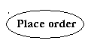
Fig: Use Cases

Third, a node is a physical element that exists at runtime and represents a computational resource, generally having at least some memory and often processing capability.
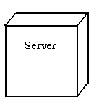
Fig: Nodes
Behavioral things are the dynamic parts of UML models. The behavioral thing used is:

Interaction:

An interaction is a behavior that comprises a set of messages exchanged among a set of objects within a particular context to accomplish a specific purpose. An interaction involves a number of other elements, including messages, action sequences (the behavior invoked by a message, and links (the connection between objects).
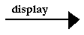
Fig: Messages

4.3.1 Relationships in the UML:

There are four kinds of relationships in the UML:
- Dependency
- Association
- Generalization
- Realization

- A dependency is a semantic relationship between two things in which a change to one thing may affect the semantics of the other thing (the dependent thing).
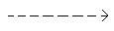
Fig: Dependencies

- An association is a structural relationship that describes a set links, a link being a connection among objects. Aggregation is a special kind of association, representing a structural relationship between a whole and its parts.
Fig: Association

- A generalization is a specialization/ generalization relationship in which objects of the specialized element (the child) are substitutable for objects of the generalized element(the parent).
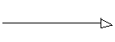
Fig: Generalization

- A realization is a semantic relationship between classifiers, where in one classifier specifies a contract that another classifier guarantees to carry out.
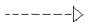
Fig: Realization

Class Diagram
An object is any person, place, thing, concept, event, screen, or report applicable to your system. Objects both know things (they have attributes) and they do things (they have methods).
A class is a representation of an object and, in many ways, it is simply a template from which objects are created. Classes form the main building blocks of an object-oriented application. Although thousands of students attend the university, you would only model one class, called Student, which would represent the entire collection of students.

Responsibilities
Classes are typically modeled as rectangles with three sections: the top section for the name of the class, the middle section for the attributes of the class, and the bottom section for the methods of the class. Attributes are the information stored about an object, while methods are the things an object or class do. For example, students have student numbers, names, addresses, and phone numbers. Those are all examples of the attributes of a student. Students also enroll in courses, drop courses, and request transcripts. Those are all examples of the things a student does, which get implemented (coded) as methods. You should think of methods as the object-oriented equivalent of functions and procedures
CLASS DIAGRAM:

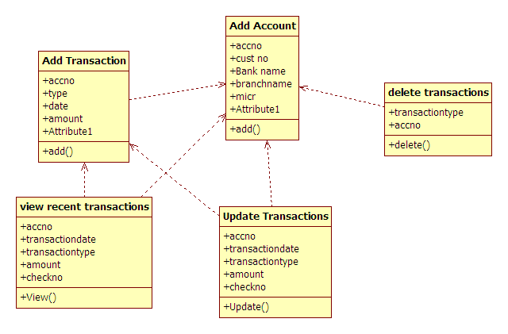

USECASE DIAGRAM
A use case diagram is a graph of actors set of use cases enclosed by a system boundary, communication associations between the actors and users and generalization among use cases. The use case model defines the outside(actors) and inside(use case) of the system’s behavior.

Use case diagram is quite simple in nature and depicts two types of elements: one representing the business roles and the other representing the business processes.
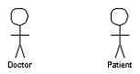
Figure 3.1: an actor in a use case diagram
To identify an actor, search in the problem statement for business terms that portray roles in the system. For example, in the statement "patients visit the doctor in the clinic for medical tests," "doctor" and "patients" are the business roles and can be easily identified as actors in the system.

Use case: A use case in a use case diagram is a visual representation of a distinct business functionality in a system. The key term here is "distinct business functionality." To choose a business process as a likely candidate for modeling as a use case, you need to ensure that the business process is discrete in nature.
As the first step in identifying use cases, you should list the discrete business functions in your problem statement. Each of these business functions can be classified as a potential use case. Remember that identifying use cases is a discovery rather than a creation. As business functionality becomes clearer, the underlying use cases become more easily evident. A use case is shown as an ellipse in a use case diagram (see Figure 3.2).
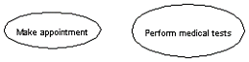
Figure 3.2: use cases in a use case diagram
Figure 3.2 shows two uses cases: "Make appointment" and "Perform medical tests" in the use case diagram of a clinic system. As another example, consider that a business process such as "manage patient records" can in turn have sub-processes like "manage patient's personal information" and "manage patient's medical information." Discovering such implicit use cases is possible only with a thorough understanding of all the business processes of the system through discussions with potential users of the system and relevant domain knowledge.

Usecase Diagram
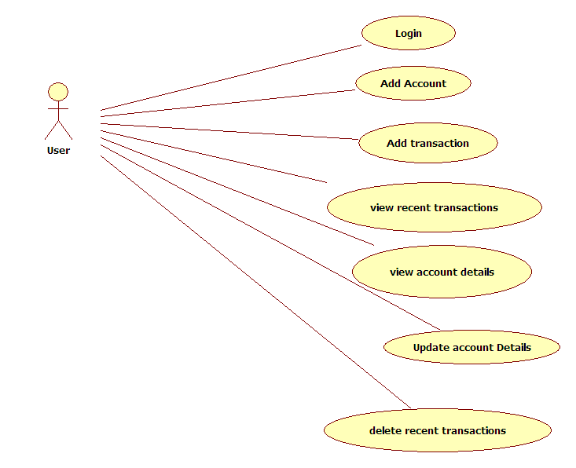

SEQUENCE DIAGRAM

UML sequence diagrams are used to represent the flow of messages, events and actions between the objects or components of a system. Time is represented in the vertical direction showing the sequence of interactions of the header elements, which are displayed horizontally at the top of the diagram.
Sequence Diagrams are used primarily to design, document and validate the architecture, interfaces and logic of the system by describing the sequence of actions that need to be performed to complete a task or scenario. UML sequence diagrams are useful design tools because they provide a dynamic view of the system behavior which can be difficult to extract from static diagrams or specifications.

Actor
Represents an external person or entity that interacts with the system

Object
Represents an object in the system or one of its components
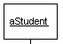
Unit
Represents a subsystem, component, unit, or other logical entity in the system (may or may not be implemented by objects)
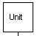
Separator
Represents an interface or boundary between subsystems, components or units (e.g., air interface, Internet, network)
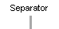
Group
Groups related header elements into subsystems or components
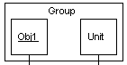

Sequence Diagram Body Elements
Action
Represents an action taken by an actor, object or unit

Asynchronous Message
An asynchronous message between header elements
Block
A block representing a loop or conditional for a particular header element 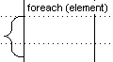

Call Message
A call (procedure) message between header elements
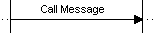
Create Message
A "create" message that creates a header element (represented by lifeline going from dashed to solid pattern)
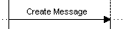

Diagram Link

Represents a portion of a diagram being treated as a functional block. Similar to a procedure or function call that abstracts functionality or details not shown at this level. Can optionally be linked to another diagram for elaboration.
Else Block Represents an "else" block portion of a diagram block
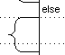
Message
A simple message between header elements
Return Message A return message between header elements
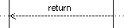
Sequence Diagram

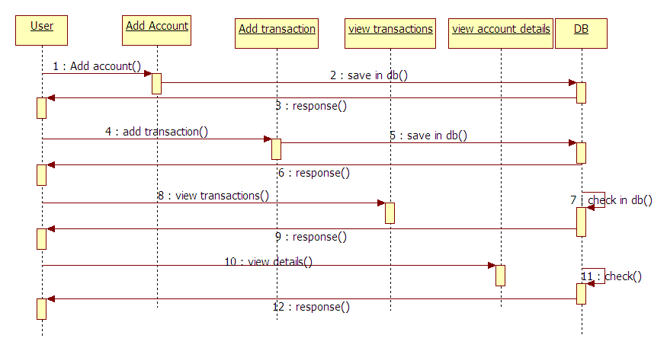

Collaboration Diagram:

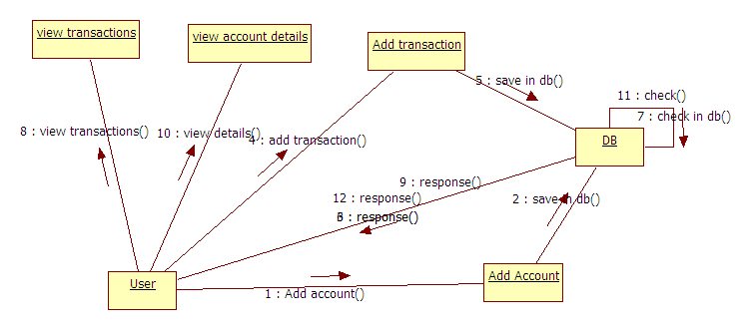

ACTIVITY DIAGRAM

Activity diagrams represent the business and operational workflows of a system. An Activity diagram is a dynamic diagram that shows the activity and the event that causes the object to be in the particular state.
So, what is the importance of an Activity diagram, as opposed to a State diagram? A State diagram shows the different states an object is in during the lifecycle of its existence in the system, and the transitions in the states of the objects. These transitions depict the activities causing these transitions, shown by arrows.
An Activity diagram talks more about these transitions and activities causing the changes in the object states.

Activity Diagram
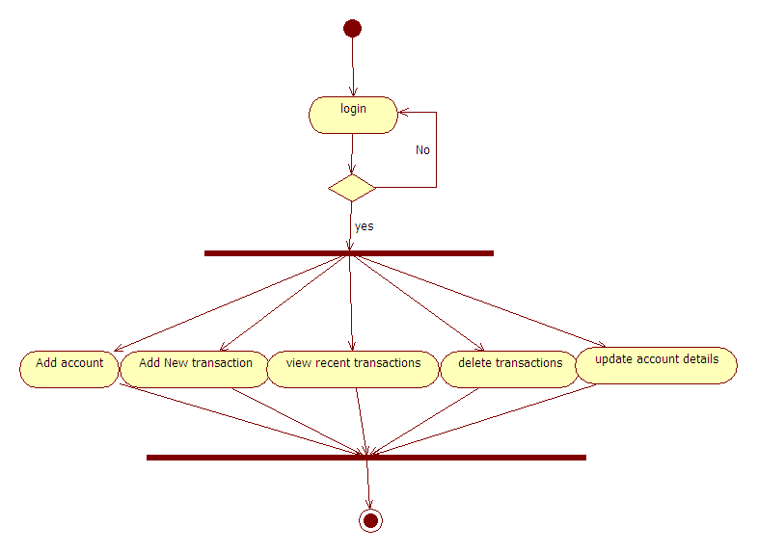

Defining an Activity diagram

Let us take a look at the building blocks of an Activity diagram.

Elements of an Activity diagram

An Activity diagram consists of the following behavioral elements:

Initial Activity: This shows the starting point or first activity of the flow. Denoted by a solid circle. This is similar to the notation used for Initial State.


Activity: Represented by a rectangle with rounded (almost oval) edges.

.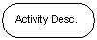

Decisions: Similar to flowcharts, a logic where a decision is to be made is depicted by a diamond, with the options written on either sides of the arrows emerging from the diamond, within box brackets.

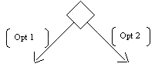

Signal: When an activity sends or receives a message, that activity is called a signal. Signals are of two types: Input signal (Message receiving activity) shown by a concave polygon and Output signal (Message sending activity) shown by a convex polygon.

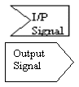

Concurrent Activities: Some activities occur simultaneously or in parallel. Such activities are called concurrent activities. For example, listening to the lecturer and looking at the blackboard is a parallel activity. This is represented by a horizontal split (thick dark line) and the two concurrent activities next to each other, and the horizontal line again to show the end of the parallel activity.
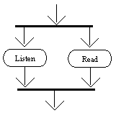

Final Activity: The end of the Activity diagram is shown by a bull's eye symbol, also called as a final activity.

STATE CHART DIAGRAM
State chart diagram is used to describe the states of different objects in its life cycle. So the emphasis is given on the state changes upon some internal or external events. These states of objects are important to analyze and implement them accurately.State chart diagrams are very important for describing the states. States can be identified as the condition of objects when a particular event occurs.
Before drawing a State chart diagram we must have clarified the following points:
- Identify important objects to be analyzed.
- Identify the states.
- Identify the events.

StateChart Diagram
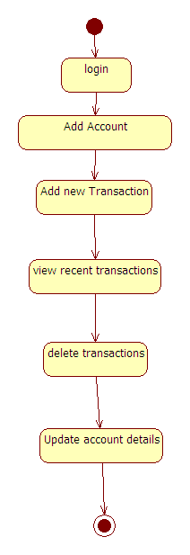

5.SYSTEM CODING & IMPLEMENTATION
Account.xml:
<?xml version="1.0" encoding="utf-8"?>

<LinearLayout xmlns:android="http://schemas.android.com/apk/res/android"
android:layout_width="match_parent"
android:layout_height="match_parent"
android:orientation="vertical">

<LinearLayout
android:layout_width="match_parent"
android:layout_height="wrap_content"
android:orientation="horizontal">
<TextView
android:id="@+id/textAccountId"
android:layout_width="wrap_content"
android:layout_height="wrap_content"
android:visibility="invisible"
android:text="" />
<TextView
android:id="@+id/textBank"
android:layout_width="wrap_content"
android:layout_height="wrap_content"
android:text="" />
<TextView
android:layout_width="wrap_content"
android:layout_height="wrap_content"
android:text="-" />
<TextView
android:id="@+id/textHolder"
android:layout_width="wrap_content"
android:layout_height="wrap_content"
android:text="" />
<LinearLayout
android:layout_width="match_parent"
android:layout_height="wrap_content"
android:layout_weight="1"
android:gravity="right"
android:orientation="horizontal">
<TextView
android:id="@+id/textBalance"
android:layout_width="wrap_content"
android:layout_height="wrap_content"
android:text="balance" />
</LinearLayout>
</LinearLayout>
<TextView
android:layout_width="match_parent"
android:layout_height="wrap_content"
android:background="#ffffff"
android:height="2dip"
android:text="" />
</LinearLayout>

Accounttransaction.xml:
<?xml version="1.0" encoding="utf-8"?>

<LinearLayout xmlns:android="http://schemas.android.com/apk/res/android"
android:layout_width="match_parent"
android:layout_height="match_parent"
android:orientation="vertical">
<TableLayout
android:layout_width="match_parent"
android:layout_height="wrap_content"
android:stretchColumns="2">
<TableRow>
<TextView
android:id="@+id/textTransId"
android:layout_width="wrap_content"
android:layout_height="wrap_content"
android:visibility="invisible"
android:text="" />
<TextView
android:id="@+id/textTransDate"
android:layout_width="70dp"
android:layout_height="wrap_content"
android:text="transdate" />
<TextView
android:id="@+id/textTransDetails"
android:scrollHorizontally="false"
android:singleLine="false"
android:layout_height="wrap_content"
android:layout_width="wrap_content"
android:text="Detaifdsfsdf dsafsdfsdf sdf fdsaf safdsafdsls" />

<TextView
android:id="@+id/textTransType"
android:layout_width="50dp"
android:layout_height="wrap_content"
android:gravity="center"
android:text="Type" />

<TextView
android:id="@+id/textAmount"
android:layout_width="wrap_content"
android:layout_height="wrap_content"
android:minWidth="70dp"
android:gravity="right"
android:text="" />
</TableRow>
</TableLayout>
<TextView
android:layout_width="match_parent"
android:layout_height="wrap_content"
android:background="#ffffff"
android:height="2dip"
android:text="" />
</LinearLayout>

5.2 SCREEN SHOTS

Home Page

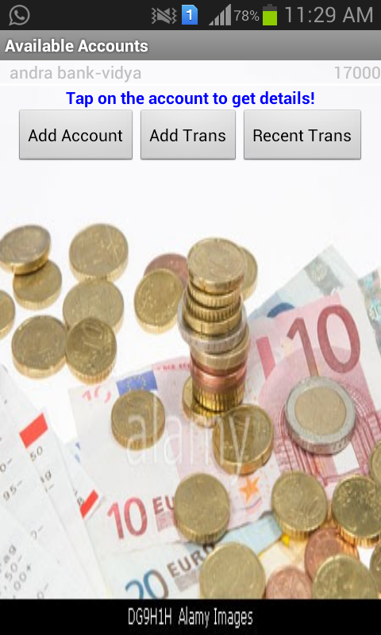

Add Account

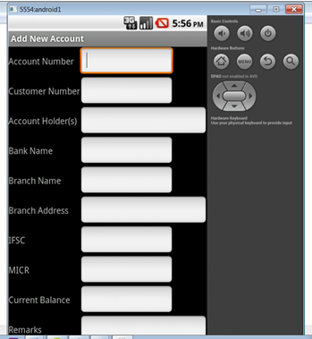

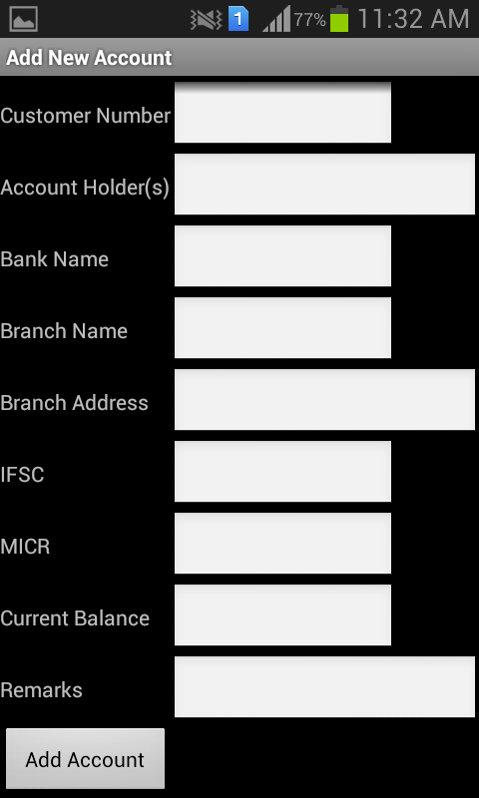

Add Deposit Transaction

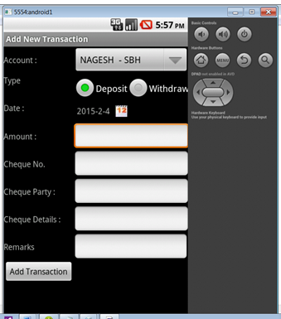

Add withdraw transaction

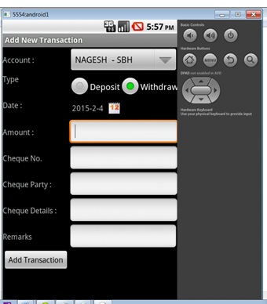
View Recent Transactions

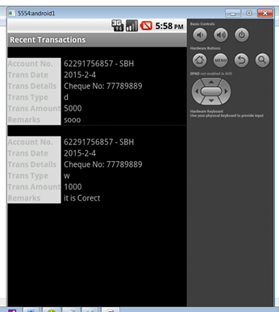

Transaction Details

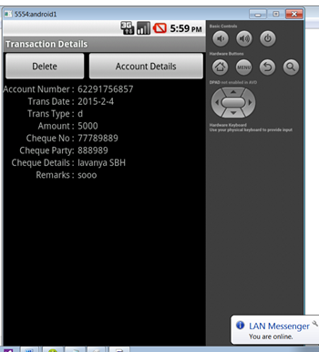
Search Details

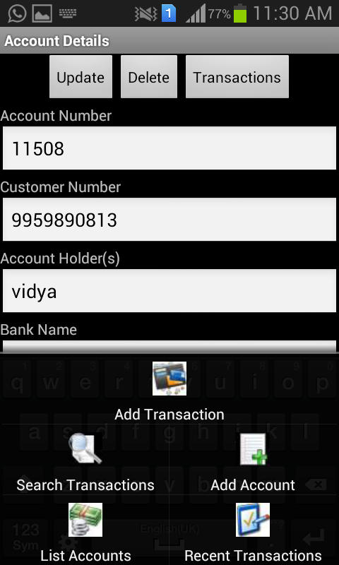

5.3 Method of Implementation

Implementation literally means to put into effect or to carry out. The system implementation phase of the software deals with the translation of the design specifications into the source code. The ultimate goal of the implementation is to write the source code and the internal documentation so that it can be verified easily. The code and documentation should be written in a manner that eases debugging, testing and modification. System flowcharts, sample run on packages, sample output etc. Is part of the implementation?
An effort was made to satisfy the following goals in order specified.
• Minimization of Response Time.
• Clarity and Simplicity of the Code.
• Minimization of Hard-Coding.
Various types of bugs were discovered while debugging the modules. These ranged from logical errors to failure on account of various processing cases.

TESTINGANDVALIDATION

5.TESTING AND VALIDATION

The development of software systems involves of a series of production activities where opportunities for injection of human fallibilities are enormous. Errors may begin to occur at the very inception of the process where the objectives may be erroneously or imperfectly specified, as well as in later design and development stages. Because of human inability to perform and communicate with perfection, software development is accompanied by a quality assurance activity.

TESTING TECHNIQUES
Testing is the process of executing a program with the intention of finding errors. The various test strategies used for testing the software are as follows.

6.1 Unit Testing

Unit testing focuses on verification effort on the smallest unit of the software design module. The main goal is to make sure that every source statement and logic path has been executed correctly at least once. The output of this stage is the source code.

6.2 Integration Testing
In Integration testing, we find errors that have occurred during the integration. After testing each module, which is then integrated into subsystems and then to form the entire system on which integration testing is performed. The goal of testing is to detect the design errors, while focusing on the testing the interconnection between modules.

6.3 Validation Testing
This testing concentrates on confirming that the software is error-free in all respects. All the specified validations are verified and the software is subjected to hard-core testing. It also aims at determining the degree of deviation that exists in the software designed from the specification; they are listed out and are corrected.

6.4 System Testing
In this testing, the system is tested for the errors after coupling all the modules together The system is tested against the specified requirements to see if all the requirements are met and the system performs as specified by the requirements

CONCLUSION

7. CONCLUSION

Conclusion
Account Tracker is a very powerful personal finance app that helps you track spending and monitor balances across multiple accounts. Its clean, intuitive user interface, and features such as alerts, bill reminders, budgets, reports and full multi-currency support, make it easy to take control of your finances.

REFERENCES

8. BIBLIOGRAPHY

- Herbert Schildt.2008 ,”Java Complete Reference”, Tata McGraw-Hill ,
7th Edition, pp.177-180 .

- Grady Booch, James Rambaugh.1998,“UnifiedModeling Language User Guide”, Addison Wesley Publishing, chapter 8-31.

WEBSITES: REFERRED URLS:

www.android.com http://developer.android.com/index.html
www.google.com http://en.wikipedia.org/wiki/SQLite

